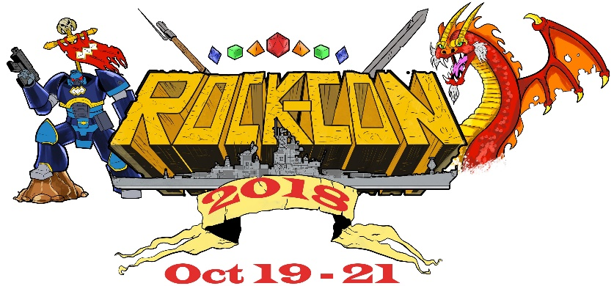

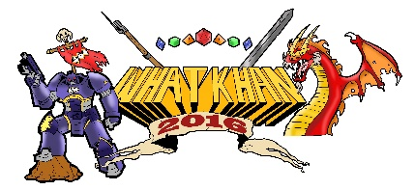

ROCK-CON is scheduled to take place October 19-21, 2018 at the Tebala Event Center – 7910 Newburg Road, Rockford, IL. The Tebala is located East of Interstate Hwy 90 using the East State Street (Business 20) exit. The location is within easy driving distance of many convenient dining locations, as well as having many hotels located within a few miles of the facility. We are currently working with several local gaming groups and area stores to bring in different activities besides scheduled gaming including a paint and take, tournaments, a board games library and company demonstrations.

- Tables - the cost is $80.00 per table or $210.00 for 3 tables, if your paperwork is received by September 1st, 2018. All tables after September 1st, will be $ 90.00 each. Each table measures 8 feet long by 30 inches wide. Your form of payment will also be due by September 1st, but will not be processed until we confirm your reservation. If a payment is refused (or bounces) the exhibitor will have one week to send the correct payment, or their reservation will be cancelled.
- For Checks/Money Orders - make out to What-Khan Convention, LLC.
- For Paypal or Credit/Debit Cards – we will send you a Paypal invoice to the email listed on the vendor registration. You can either use your Paypal account or a credit/debit card through the PayPal site.
- Wifi and Power – Rock-Con will have access to the facility’s wireless network and power supply. Please let us know on your registration form if you will need access to the power grid. Login in information for the wireless network will be available on site.
- Table Assignments – The Rock-Con staff will do their best to make sure all table requests are honored. If our Exhibitors Area becomes oversold; we may limit the number of tables per Exhibitor. Any overage of fees will be refunded.
- Games or Demonstrations. If you are interested in running demonstrations, please let us know. We are encouraging Exhibitors to sponsor events on our game floor. If you are interested in participating, please contact us games@rock-con.com for our sponsorship packet.
- Donations for Door Prizes - Are always welcome! Exhibitors may place advertising on the product and donors will be announced in both the program and during the door prize drawings. If you let us know beforehand what you would like to donate; we can advertise the donation on our website. A thumbnail of your logo will appear with the description or picture of the item.
- Program Advertising - Exhibitors are welcome to advertise in our event program. All exhibitors will receive a free “business card” sized (1/8 page) advertisement. For an additional cost you can upgrade your ad size, and additional information is listed on our application form. For printing, we will need a high-resolution digital image by October 1st, 2018.
- Website Advertising - We are offering free space for exhibitors. Your Logo will be featured on the Exhibitors page and will link back to your website or social media page until the end of 2018. For the website, we will need a high-resolution digital image of your logo sent to registration@rock-con.com.
- Hotels – At this time we are working on acquiring a room block at a local hotel. We will announce the block when we have more information. Or you can check www.hotels.com or www.gorockford.com for local deals.

Sincerely,

Antina Richards-Pennock  Rock-Con  Convention Coordinator  games@rock-con.com | Scott King-Johnson  Rock-Con  Exhibitor Coordinator  exhibitors@rock-con.com | Danielle Vance  Rock-Con  Convention Registrar  registration@rock-con.com

 |  | 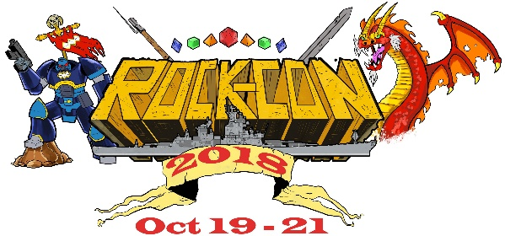  Vendor Move In Starts: 10/19/18 @ 12 PM |  | ROCK-CON Convention  Vendor Registration Form  Deadline September 1, 2018
 |  |  |  | Mail Your Form To:  What-Khan Convention  P.O. Box 10032  Loves Park, IL 61111 |  |  |  |  | Email Your Form & High-res Digital Image for the Program To:  registration@rock-con.com
 | Company Name:
 | Contact Person:
 | Mailing Address:
 | Telephone #: |  |  |  |  |  | FAX #
 | Email Address:
 | Web OR Social Media Address: |  | Link will be used on the Vendor Page of the website. Please send us jpg banner to email above ASAP
 | Number of Tables Requested: |  | Prior to 9/1 $ 80.00 per table, OR  $210.00 for 3 tables |  |  |  |  |  |  |  | ____ @ 80.00  ____ @210.00
 |  |  | Price After 9/1 $ 90.00 per table |  |  |  |  |  |  |  | _____@90.00
 | Badge Requests:  2 badges for the first table, 1 badge for each additional table. Further badges will be $ 8.00 each. |  | Names:  1.____________________________  2.____________________________  3.____________________________  4.____________________________ |  |  |  |  | Names:  5.____________________________  6.____________________________  7.____________________________  8.____________________________
 | Advertising in our Convention Program: |  | - Business Card Size FREE  Upgrades Available  - ¼ Page Ad $11.00  - ½ Page Ad $22.00  - Full Page Ad $40.00 |  |  |  |  | We will need a high-resolution digital image of your ad copy for our program by October 1st, 2018.
 | Special Requests: |  |  |  |  |  |  | Do you need access to electrical outlets? Yes No
 | Payment:  __ Check or Money Order (make payable to What-Khan Convention)  __ Paypal (will send invoice to the email on this form)  __ Visa or MasterCard (will call the phone number listed for  processing information) |  |  |  |  | Total from Tables |  |  |  |  |  | $
 |  |  |  |  |  | Total from Badges |  |  |  |  |  | $
 |  |  |  |  |  | Total from Advertising |  |  |  |  |  | $
 |  |  |  |  |  | Grand Total |  |  |  |  |  | $

Please note that this year, we have decided not to request or enforce any product exclusivity. Any vendor may bring any game, game-related product or collectible item to sell at Rock-Con with the following exceptions:
- No pornographic material
- No Food or Drinks
- No firearms, ammunition, knives, swords or explosives (including replicas).
- No illegal material (under the laws of the United States or the State of Illinois)
- No subletting of tables or booth without prior approval of the management.
- Vendors are individually responsible to the State of Illinois for any owed State Sales Tax. Tax Rate as of 4/4/2018 was 8.25%

